

***HTML Essentials***

**Lab Guides**

|  |  |
| --- | --- |
| Document Code | 25e-BM/HR/HDCV/FSOFT |
| Version | 1.1 |
| Effective Date | 20/11/2012 |

**Hanoi, 04/2019**

RECORD OF CHANGES

|  |  |  |  |  |  |
| --- | --- | --- | --- | --- | --- |
| No | Effective Date | Change Description | Reason | Reviewer | Approver |
|  | 25/Jun/2018 | Create a new Lab | Create new | DieuNT1 | VinhNV |
|  | 01/May/2019 | Update Fsoft Template | Update | DieuNT1 | VinhNV |
|  |  |  |  |  |  |
|  |  |  |  |  |  |
|  |  |  |  |  |  |
|  |  |  |  |  |  |
|  |  |  |  |  |  |
|  |  |  |  |  |  |
|  |  |  |  |  |  |
|  |  |  |  |  |  |

Contents

Unit 4 – Hyperlinks 4

Lab Objectives: 4

Problem Descriptions: 4

Guidelines: 5

Step 1: Analyze Requirements 5

Step 2: Build the structure 5

Step 3: Add more details 5

Step 4: Code HTML 6

Step 5: Verify Output 6

|  |  |
| --- | --- |
|  | **CODE: HTML-E.S.L401**  **TYPE: Short**  **LOC: N/A**  **DURATION: 30 MINUTES** |

# Unit 4 – Hyperlinks

## Lab Objectives:

* Understand Structural hierarchy
* Able to use Heading, Paragraph
* Able to use List

## Problem Descriptions:

Using <a> tag to create the Image Search Listing web:

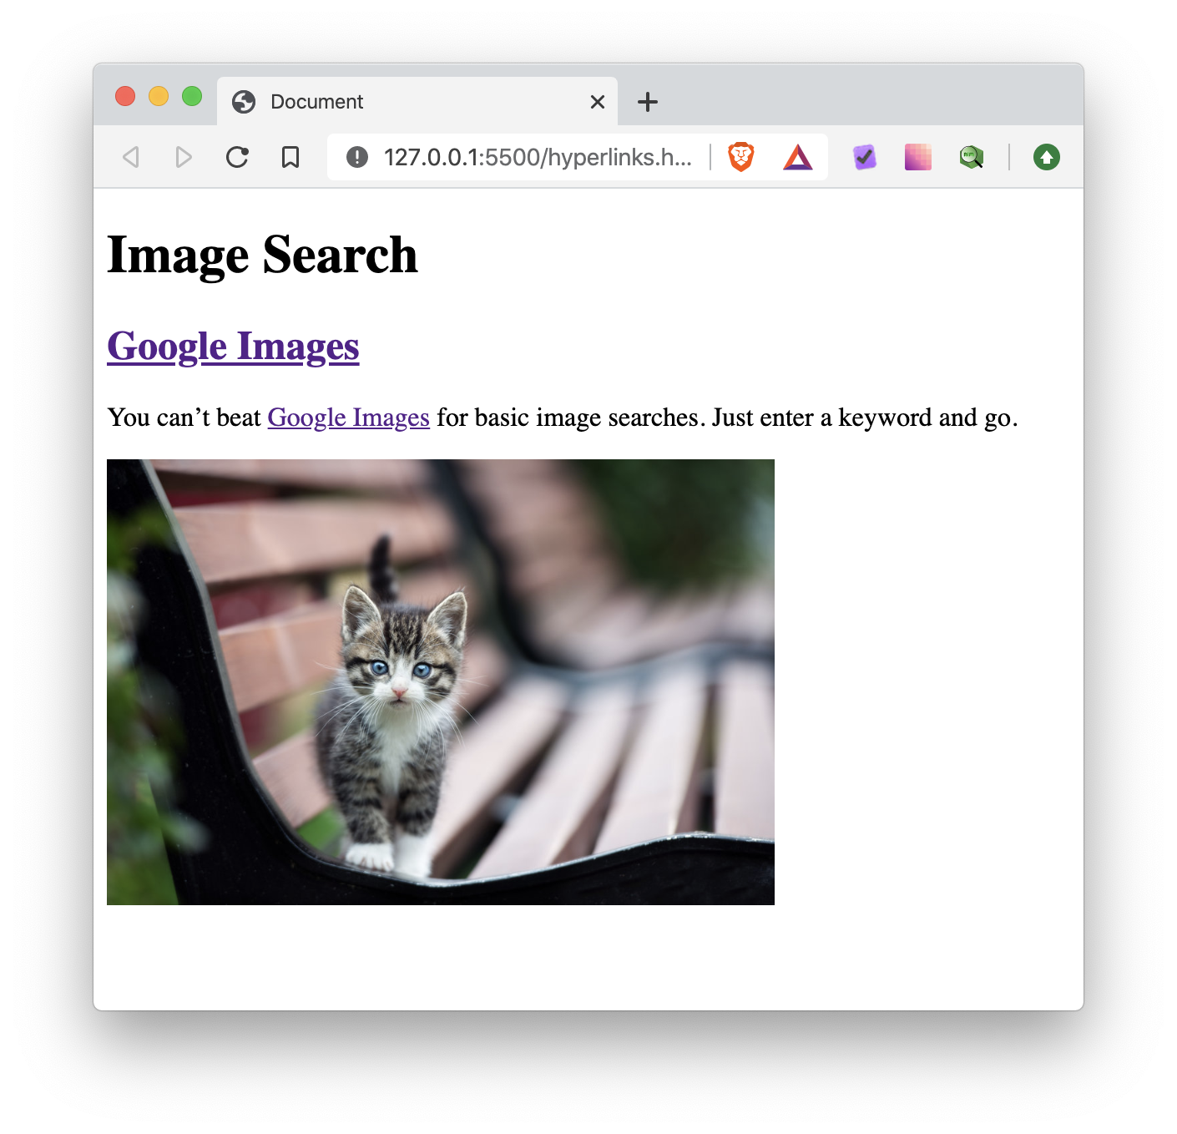

## Guidelines:

Step 1: Analyze Requirements

Firstly, we must analyze the output and identify as much elements as possible. By going from top to bottom, we check each block and have the result below:

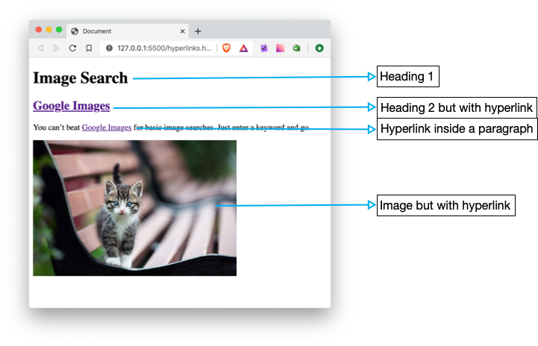

Step 2: Build the structure

Next, we will transform each element identified above to HTML elements.

* Heading 1 will be <h1>…</h1>
* Heading 2 will be <h2> (or <h3> but never be <h1>) inside a <a> tag: <h2><a></a></h2>
* Next item is a <p> with <a> tag inside: <p>You can’t beat <a>Google Images</a>…</p>
* Image is a <img> wrapped inside in <a> tag: <a><img></a>

Step 3: Add more details

After come up with the HTML elements, we must fill now the content and details else we can’t see any thing

Heading 1 is simply:

1. <h1>Image Search</h1>

Heading 2 is:

1. <h2>
2. <a href="https://images.google.com" target="_blank" >Google Images</a>
3. </h2>

For the paragraph, we fill in the text and wrap Google Images inside an <a> tag:

1. <p>
2. You can’t beat <a href="https://images.google.com">Google Images</a> for basic image searches. Just enter a keyword and go.
3. </p>

Lastly, we add an image and wrap inside an <a> tag:

1. <a href="https://images.google.com">
2. <img width="400px" src="https://images.squarespace-cdn.com/content/v1/55e7b445e4b04e7d0095c2cd/1556296318516-36C15R1S3A4H1GUP62QL/ke17ZwdGBToddI8pDm48kFyD7pzB8zoMIVY5aiUuFlp7gQa3H78H3Y0txjaiv_0fDoOvxcdMmMKkDsyUqMSsMWxHk725yiiHCCLfrh8O1z4YTzHvnKhyp6Da-NYroOW3ZGjoBKy3azqku80C789l0jG2lbcDYBOeMi4OFSYem8DMb5PTLoEDdB05UqhYu-xbnSznFxIRsaAU-3g5IaylIg/AdobeStock_170586850+%281%29.jpeg" alt="Google Images" >
3. </a>

Step 4: Code HTML

Finally, we put every piece together and come up with fully working code.

1. <!DOCTYPE html>
2. <html lang="en">
3. <head>
4. <meta charset="UTF-8">
5. <meta name="viewport" content="width=device-width, initial-scale=1.0">
6. <title>Document</title>
7. </head>
8. <body>
9. <h1>Image Search</h1>
11. <h2>
12. <a href="https://images.google.com" target="_blank" >Google Images</a>
13. </h2>
14. <p>
15. You can’t beat <a href="https://images.google.com">Google Images</a> for basic image searches. Just enter a keyword and go.
16. </p>
18. <a href="https://images.google.com">
19. <img width="400px" src="https://images.squarespace-cdn.com/content/v1/55e7b445e4b04e7d0095c2cd/1556296318516-36C15R1S3A4H1GUP62QL/ke17ZwdGBToddI8pDm48kFyD7pzB8zoMIVY5aiUuFlp7gQa3H78H3Y0txjaiv_0fDoOvxcdMmMKkDsyUqMSsMWxHk725yiiHCCLfrh8O1z4YTzHvnKhyp6Da-NYroOW3ZGjoBKy3azqku80C789l0jG2lbcDYBOeMi4OFSYem8DMb5PTLoEDdB05UqhYu-xbnSznFxIRsaAU-3g5IaylIg/AdobeStock_170586850+%281%29.jpeg" alt="Google Images" >
20. </a>
21. </body>
22. </html>

Step 5: Verify Output

* Save the HTML code from Step 4 into **index.html** file
* Open it with Live Server and verify the output

**-- THE END --**